Steps of implementation: Document Summary Generation

Objective

Our primary objective is to develop a robust document summary generation system. This system will process diverse financial reports from various companies, specifically extracting and structuring data from their financial tables.

The core functionality will involve users uploading PDF documents containing these financial reports. Upon upload, the system will analyse the reports to identify and extract financial tables and related text. Subsequently, it will store the textual and tabular data. A user will query using the CSV/Excel file that consolidates user-defined essential financial report sections. The system will generate the CSV/Excel file of those sections with quarter-wise numbers. This will significantly reduce manual data extraction efforts and enhance efficiency in financial reporting and analysis.

Steps
Step 1: Ingestion
The initial phase involves the ingestion of documents into the system. Users will upload their financial documents exclusively in PDF format. This standardisation ensures compatibility and streamlines the subsequent processing steps. The system is designed to receive and prepare these PDF files for further analysis.
Each Size of the PDF will be limited to a maximum of 10 MB and a maximum of 10 files at a time.
Step 2: Extraction of Table and Text from the PDF
This crucial step focuses on meticulously extracting both textual and tabular data from the uploaded PDFs. To achieve this, the system leverages specialised libraries:
- Camelot and PDFPlumber: These libraries are employed for the robust extraction of textual data from the PDF documents. Their capabilities allow for the accurate parsing of diverse text layouts and structures within financial reports. Once extracted, this textual information is stored, forming a foundational context for the Language Model (LLM).
- Table Detection and Data Extraction with LLM: The system is equipped to detect tables within the PDF pages. For the extraction of data from these detected tables, it utilises an advanced LLM model, such as one based on OpenAI's technology. This LLM is not only used for Optical Character Recognition (OCR) to convert images of text within tables into a machine-readable format, but also plays a critical role in the correction and refinement of tabular data. This ensures the accuracy and integrity of the extracted financial figures.
- Context Storage for LLM: Both the extracted textual data and the refined tabular data are then stored as context. This comprehensive context is vital for the LLM model in subsequent steps, providing it with all the necessary information to understand and process the user's queries effectively.
Step 3: User Query
In this phase, the user actively interacts with the system to specify their data requirements:
- CSV/Excel File for Financial Report Sections: Users will provide a CSV or Excel file that precisely outlines the financial report sections for which they desire data. This allows for targeted data retrieval, ensuring the system focuses on the specific information relevant to the user's analytical needs.
- PDF Parsed Data and CSV Output Generation (RAG Model): The system then utilises the previously parsed PDF data to generate a CSV output. This process is powered by a Retrieval-Augmented Generation (RAG) model. All the processed PDF data is vectorised, meaning it's converted into numerical representations that capture its semantic meaning. These vectorised representations are stored within a vector database, which serves as a highly efficient retriever for the LLM. When a user query is received, the RAG model uses this vector database to retrieve the most relevant pieces of information from the stored PDF data, which then guides the LLM in generating accurate and contextually appropriate CSV output data.
Step 4: Output Generation
The final step delivers the requested financial data to the user:
- Requested Financial Data Output: The system consolidates all the requested financial data, extracted and processed from the various PDF companies, and presents it to the user. This output is a comprehensive compilation of the specific financial information that the user initially specified, provided in excel/csv file format.

Workflow Diagram:
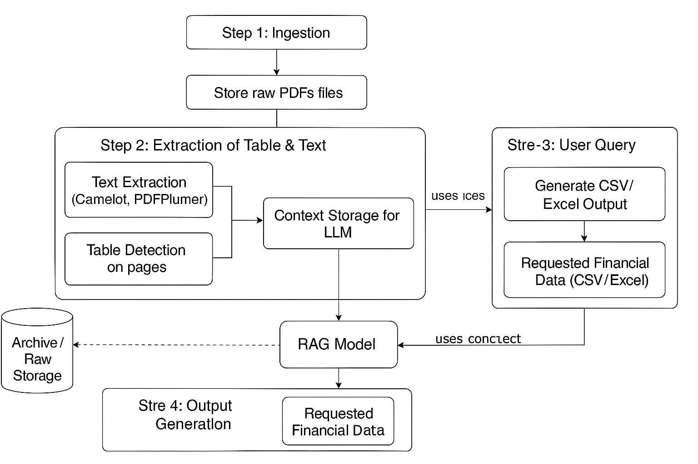

Risks and Challenges:
- In some financial documents, tables are presented as images and cannot be extracted using standard text extraction libraries; OCR libraries are required.
- Local OCR solutions, such as Paddle OCR, may not accurately detect all data, and the table structure can be lost.
- Even with LLM-based approaches, data extracted via OCR may still contain inaccuracies in some instances.
- When extracting specific company and table field values, hallucination can occur, leading to the inclusion of data from other companies.

Cost Calculation:
- Cost calculation for the LLM-based OCR extraction:

Assumptions
- Input tokens: 30,000 tokens
- Output tokens: 2,500 tokens
- Pricing for GPT-4o mini: ~$0.15 per 1 000 000 input tokens (i.e. $0.15 per 1 M) and ~$0.60 per 1 000 000 output tokens (i.e. $0.60 per 1 M
- We’ll calculate the cost for one single call with those token counts.

Cost calculation
- Input cost:
Input tokens=30,000
Price is $0.15 per 1,000,000 tokens → cost per token = $0.15 / 1,000,000 = $0.00000015 per token.
Input cost=30,000×$0.00000015=$0.0045\image
- Output cost:
Output tokens=2,500
Price is $0.60 per 1,000,000 tokens → cost per token = $0.60 / 1,000,000 = $0.00000060 per token.
Output cost=2,500×$0.00000060=$0.0015\image
- Total cost for one call:
$0.0045 + $0.0015 = $0.0060+ \$0.0015 = $0.0060
So around $0.006 (six tenths of a cent) per call with those token counts.

